
  - Norscot - New Requirement – External Registration Form

Functional Requirements Document (FRD)

Copyright© 2021, Oracle and/or its affiliates. All rights reserved.
Any reproduction or distribution of any part of this document without the prior written permission of Oracle + NetSuite is strictly prohibited.
The information included in this document is confidential and proprietary information of Oracle + NetSuite.
Version: November 16, 2021

Oracle + NetSuite
2955 Campus Drive, Suite 100
San Mateo, CA. 99403-2511

Project Information
Customer Name (Number) | Norscot
Job Name (Number) | J930417
Document Owner | Alain Komin
Solution Architect | Ilan Daniele
Project Manager | Alain Komin

Document Version History
Rev | Date | Author(s) | Change Summary
1.0 | 07/21/2023 | Alain Komin | Initial Draft

Business Requirements
Norscot requested a new functionality for the CAT site to display a button in the native login page to take the customer to an external registration form.

Solution Overview
Norscot owns the CAT webstore and it is a password protected site and no one can register on it.
It is needed to add a link to an external form that we need to create with the next Customer record fields:

- First Name
- Last Name
- Company
- Phone Number
- Street Address
- Zip Code
- Country
- State
- Email Address
- Password
- Repeat Password
- Dealer No. (custentity_dealer_no)
- Assigned website: CAT Norscot Site (id=11)

Once the form is submitted by pressing the Submit button, a new Lead will be created without access to the store.
A confirmation or error message will be displayed providing information to the user.
This message will be set in the configuration record.

The URL of this external form will be similar to this one: https://4890397.extforms.netsuite.com/app/site/crm/externalleadpage.nl/compid.4890397/.f?formid=1&h=AAFdikaIiOfSHO9_ba90PKAUQOyGDRYbIWDOKSylHzM-P8ltAlU&redirect_count=1&did_javascript_redirect=T

Screens
Staging URL: https://staging.cat.norscotsites.com/

Login page:
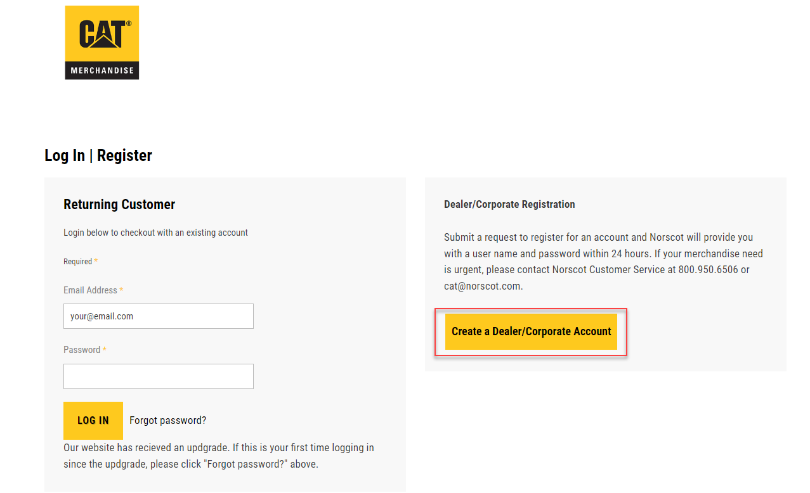

The “Create a Dealer/Corporate Account” button will open a new browser’s tab and show the customer registration form. Example below:
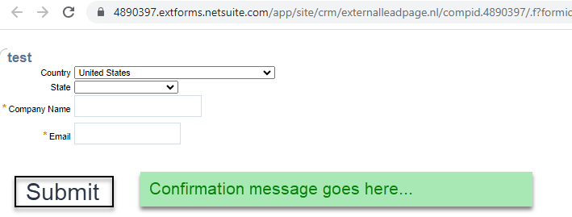
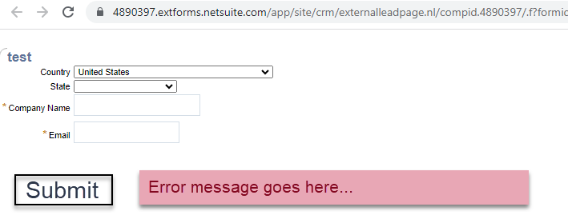
The confirmation and error messages will be set in the Configuration Record as new fields or as keys in the Multi Language tab.
HTML will also be added to improve the look and feel to match the CAT site.

Acceptance
Oracle + NetSuite Professional Services and Customer are in agreement that the information documented above is accurate and representative of the customer’s business needs. This document will act as the basis for all subsequent implementation activities.
Delivery Date: 07/21/2023
Document Version: 1.0

Oracle + NetSuite Acceptance
Action | Name | Title | Signature | Date
Accepted By |  | Project Manager
Accepted By |  | Consultant

Customer Acceptance
Action | Name | Title | Signature | Date
Accepted By |  | Project Manager

